Revision 1
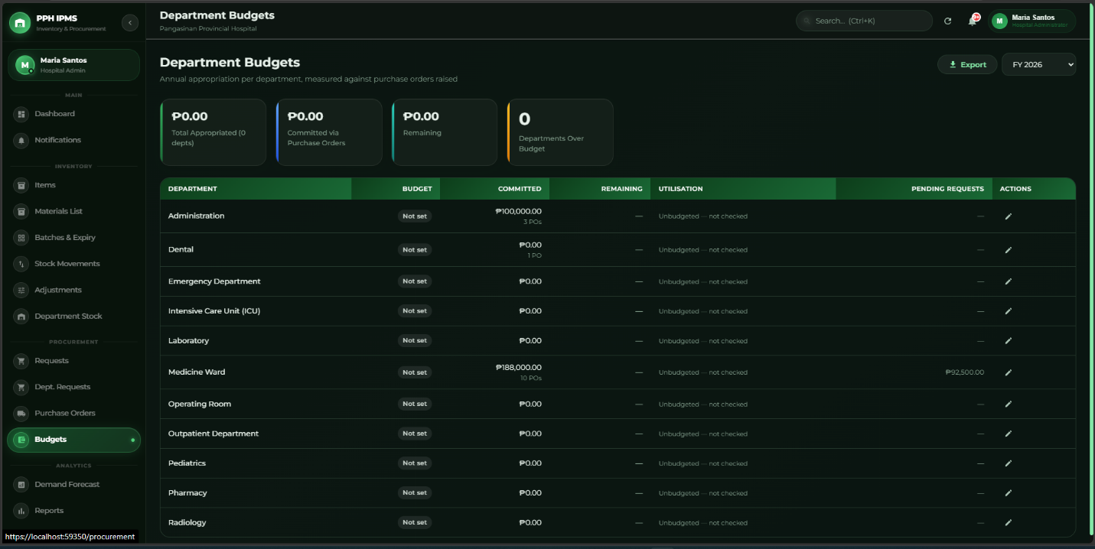

Dapat po tanggalin na lahat ng budget-related features sa system, since hindi naman po PPH ang may hawak or nagma-manage ng hospital budget. So hindi na po kailangan ng Department Budgeting, Department Budget, Budget Allocation, Budget Tracking, or any other budget-related fields/functions.
For the Estimated Cost, since part din siya ng budget-related information required talaga siya for the Purchase Request, Requesition and issue slip, Request Slip dapat optional po talaga dapat meron padin po yun sir kasi part padin sya
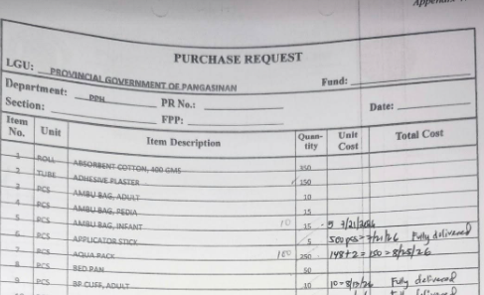

Revision 2
Dito po sa Super Admin account, dapat may Forgot Password function din. Para kung makalimutan ng Super Admin yung password niya, may option siyang mag-reset ng password through the proper password recovery process. Hindi dapat excluded yung Super Admin sa Forgot Password feature para may way pa rin siyang makapag-recover ng account without manually changing the password directly sa database.

Revision 3
Dapat po may Urgent/Emergency Request option, kasi may mga urgent na supplies na kailangan ma-process agad. Kapag pinili po na urgent/emergency, dapat may reason or justification kung bakit kailangan siyang i-prioritize, and dapat justifiable daw po yung nag request or may valid reason na kailangan na daw itong bilhin.

Revision 4
Dapat po may proper status tracking sa mga requests. Para makita kung pending, approved, forwarded, or ongoing pa yung request at hindi na kailangan manually mag-follow up para malaman yung status.

Revision 5
Dapat po may warning kapag nagre-request ng item na sufficient pa yung stock, kasi according sa client, may mga instances na nagre-request pa rin kahit available naman yung item, which can result in excess inventory. So dapat ma-inform muna yung user na sufficient pa yung stock bago ituloy yung request.

Revision 6
Sa receiving/delivery part, dapat po may way para ma-record kung may problem sa delivery, tulad ng delayed, incomplete, damaged, or substandard yung mga items na dumating.

Revision 7
Dapat po may approval sa inventory correction kapag may discrepancy, kasi according sa client, yung correction ay ginagawa ng Inventory Head with approval ng Head of Property & Supply. So hindi dapat basta-basta ma-edit ng user yung stock quantity kapag may discrepancy.

